Jewish-German Culture
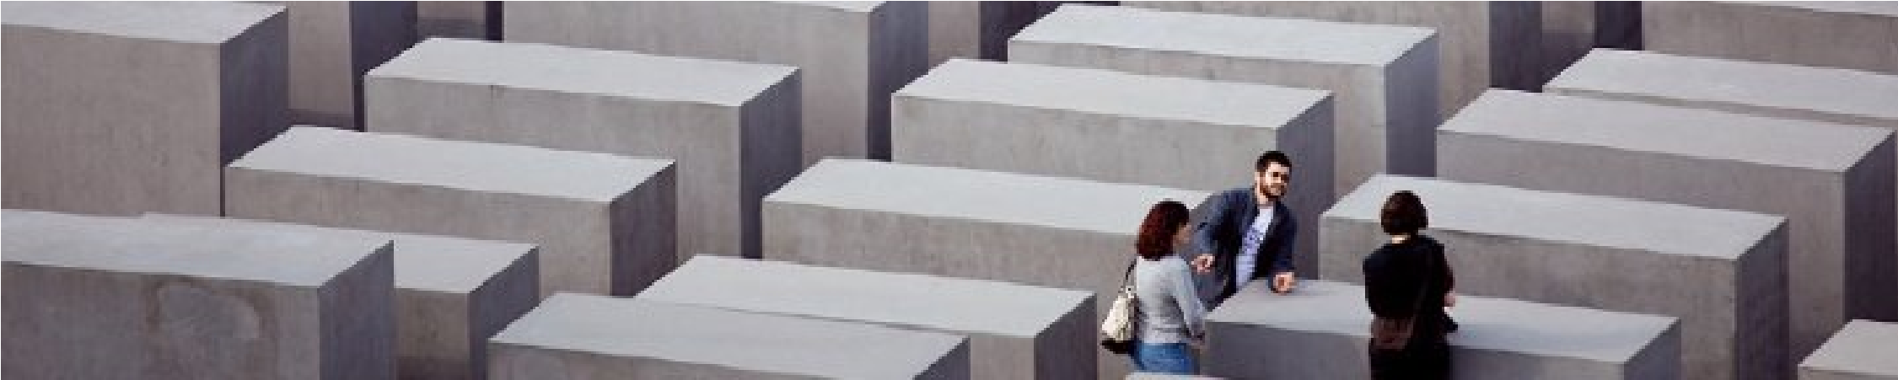
HOLOCAUST MEMORIAL B
ERLIN

Memorial to the Murdered Jews of Europe with exhibition at the Information
Centre

The Memorial to the Murdered Jews of Europe in the centre

of Berlin is the
German Holocaust Memorial honouring and remembering the up to six million
Jewish victims of the Holocaust.

Location: Between Brandenburg Gate and Potsdamer Platz

Stele
–

pl. Stelae (also Steles)

• a stone or wooden slab, generally taller than it is wide, erected in the ancient world as a monument. Grave steles were often used for funerary or commemorative purposes.

The Field of Stelae

The final design, approved on 25 June 1999 (»Eisenman II«), envisages around
2,700 concrete slabs (stelae), arranged in a grid pattern. They are 0.95 cm deep and 2.38 m wide and vary only in height. The stelae stand on gently and unevenly sloping ground covering 19,000 square metres. The public is able to enter and walk through the field from all four sides. They experience the wave-like form differently from each different position.

The extraordinary design by Peter Eisenman, New York architect of international renown, has undergone several revisions and represents a radical confrontation with the traditional concept of a memorial.

»The enormity and scale of the horror of the Holocaust is such that any attempt to represent it by traditional means is inevitably inadequate ... Our memorial attempts to present a new idea of memory as distinct from nostalgia ... We can only know the past today through a manifestation in the present.« (Peter Eisenman, 1998)

The Architect:
Peter Eisenman about the Memorial

Architecture is about monuments and graves, said the Viennese architect Adolf Loos at the turn of the 20th century. By this he meant that an individual human life could be commemorated by a stone, a slab, a cross, or a star.

The simplicity of this idea ended with the Holocaust and Hiroshima and the mechanisms of mass death. Today an individual can no longer be certain to die an individual death, and architecture can no longer remember life as it once did.

The markers that were formerly symbols of individual life and death must be changed, and this has a profound effect on the idea of memory and the monument. The enormity and horror of the Holocaust are such that any attempt to represent it by traditional means is inevitably inadequate.

The memory of the Holocaust can never be one of nostalgia.

The context of the Memorial to the Murdered Jews of Europe is the enormity of the
banal.

The project manifests the instability inherent in what seems to be a system, here a rational grid, and its potential for dissolution in time. It suggests that when a supposedly rational and ordered system grows too large and out of proportion to its intended purpose, it in fact loses touch with human reason. It then begins to reveal the innate disturbances and potential for chaos in all systems of seeming order, the idea that all closed systems of a closed order are bound to fail.

Remaining intact, however, is the idea that the pillars extend between two undulating grids, forming the top plane at eye level. The way these two systems interact describes a zone of instability between them.

[…]

This divergence denotes a difference in time, between what the philosopher Henri Bergson called chronological, narrative time and time as duration. The monument’s registration of this difference makes for a place of loss and contemplation, elements of memory.

The Ort is subdued in manner, effectively designed to minimize any disturbance
to the Memorial’s field of pillars.

In a prescient moment in »In Search of Lost Time«, Marcel Proust identifies two different kinds of memory: a nostalgia located in the past, touched with a sentimentality that remembers things not as they were but as we want to remember them, and a living memory, which is active in the present and devoid of nostalgia for a remembered past. The Holocaust cannot be remembered in the first, nostalgic mode, as its horror forever ruptured the link between nostalgia and memory. Remembering the Holocaust can therefore only be a living condition in which the past remains active in the present.

In this context, the monument attempts to present a new idea of memory as distinct from nostalgia. We propose that the time of the monument, its duration, is different from the time of human experience and understanding. The traditional monument is understood by its symbolic imagery, by what it represents. It is not understood in time, but in an instant in space; it is seen and understood simultaneously. Even in traditional architectures such as labyrinths and mazes, there is a space-time continuum between experience and knowing; one has a goal to work one’s way in or out.

In this monument there is no goal, no end, no working one’s way in or out. The duration of an individual’s experience of it grants no further understanding, since understanding is impossible. The time of the monument, its duration from top surface to ground, is disjoined from the time of experience. In this context, there is no nostalgia, no memory of the past, only the living memory of the individual
experience. Here, we can only know the past through its manifestation in the
present.

REPLICA CREATED IN 2017 AS PROTEST AGAINST AFD

ARTS
Guerrilla artists build Holocaust memorial next to far-right leader's home
Renowned for ambitious guerrilla actions, the artist collective Center for Political Beauty unveiled their latest project: a replica of Berlin's Holocaust Memorial set up next to right-wing AfD leader Björn Höcke's home.

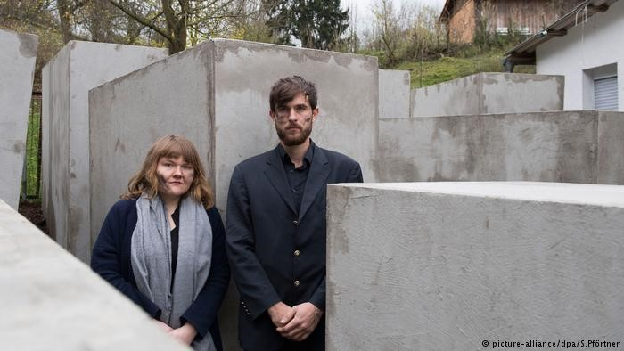
The Berlin-based art activist collective Center for Political Beauty (Zentrum für Politische Schönheit) is at it again.
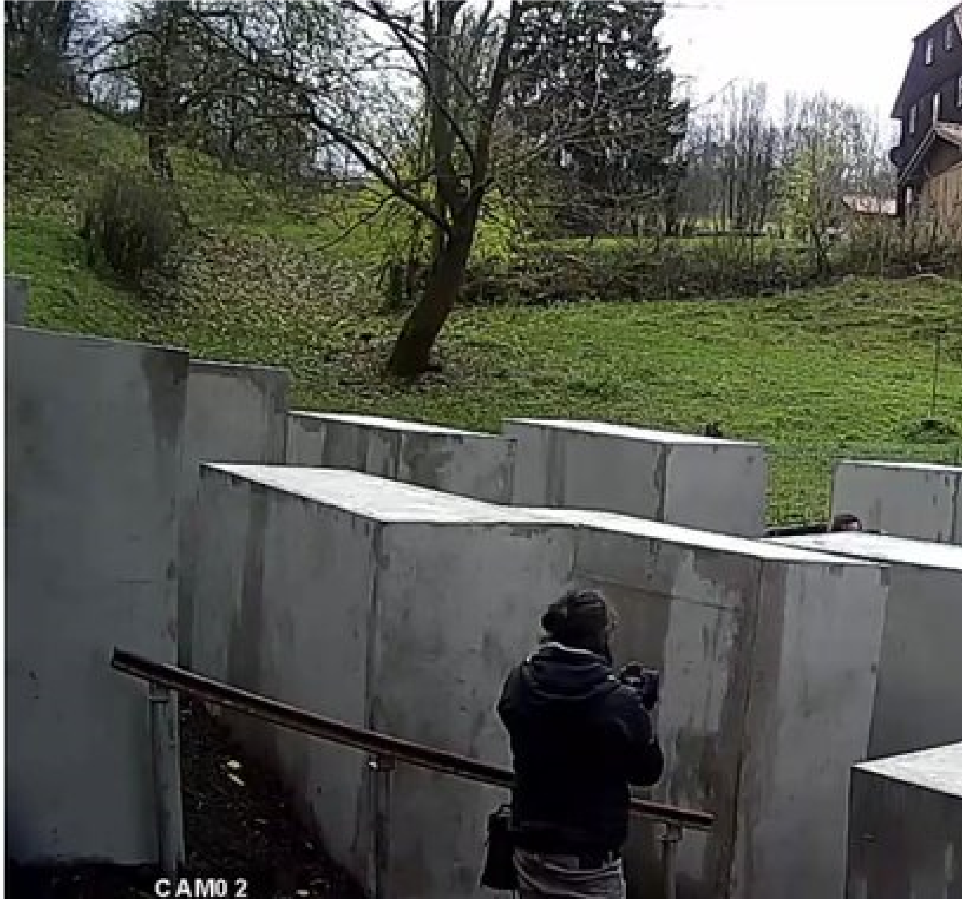
Early on the morning of Wednesday, November 22, 2017, the group publicized their next action: to build a replica of the "Memorial to the Murdered Jews of Europe," on the doorstep of the AfD's Björn Höcke, a politician known for his sharp criticism of the Holocaust Memorial in Berlin.
Before mid-day, the guerrilla artwork had been completed, with 24 cement stelae of varying sizes erected on a private property neighboring Björn Höcke's house in a village in Thuringia.

Shahak Shapira
Meine Freunde von @politicalbeauty haben dem Bernd Höcke ein
Holocaustmahnmal direkt vor die Tür gebaut. Er braucht es auch am dringendsten. 5:01 AM - Nov 22, 2017
•
7373 Replies

•
633633 Retweets

•
2,3542,354 likes
"My friends from @politicalbeauty have built a Holocaust memorial directly in front of Bernd [sic, the name has often been used for him by German satirists instead of Björn] Höcke's door. He does need it most urgently," tweeted Berlinbased Israeli comedian Shahak Shapira.
Höcke gained media attention after giving a controversial speech in Dresden in
January in which he called for a 180-degree shift in the way that the history of World War II is considered, and referred to the Berlin memorial as a "Monument of shame."
Read more:Leading German politician calls AfD's Höcke a 'Nazi'
The comments sparked a furor for which the head of the Thuringian branch of the Alternative for Germany party later apologized.
The Center for Political Beauty has responded by setting up what they call a "civil society defense of the constitution" group in Thuringia, aimed at the "long-term tracking of right-wing extremists in Germany."
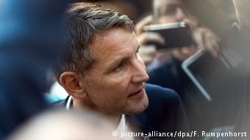
Höcke continues to grab media attention, most recently at the Frankfurt Book Fair in October, after people protested his presence

A deal for its removal
As the artists explained in a video, "Because Höcke is a 'secret admirer' of the memorial, we are building one for him directly on his doorstep."
Members of the group of activists said they have been anonymously living as neighbors, "sharing a fence with the right's 'poster boy'" and would only remove the art, which is planned to remain through 2019, once the politician agreed to a deal: If Höcke were to fall to his knees in front of the Holocaust Memorial in order to beg forgiveness for Germany's actions during World War II, as
former chancellor Willy Brandthad once infamously done, the collective said they would stop their action.
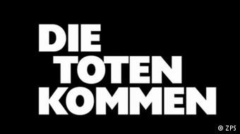
The Center for Political Beauty is known for their hard-hitting political commentary and slogans like this one, which reads "The dead are coming"

Center for Political Beauty: renowned for controversial actions
It is not the first time that the Center for Political Beauty has grabbed headlines for their guerrilla actions.
Most recently, the collective made waves with aG20 protest titled, "Kill the dictator."
Last year, they threatened to feed refugees to a tiger in a performance at the Gorki Theater in Berlin aimed at increasing awareness of the plight of refugees stuck in Turkey.
In 2015, the group laid coffins out in front of the Reichstag to highlight the refugee crisis, an action for which they received a Bobs Award from the Deutsche Welle Global Media Forum in 2016.

New Holocaust Memorial Ottawa

http://holocaustmonument.ca/

